Executive Summary: Blockchain Technology and Archives
By: Darra L. Hofman, Blockchain@UBC, iSchool, University of British Columbia

Introduction
Blockchain technology is, fundamentally, a recordkeeping technology. While there is no universally agreed upon definition of “blockchain technology,” it is largely agreed to be “a distributed ledger that maintains a continually growing list of publicly accessible records cryptographically secured from tampering and revision” (Lemieux 2016, 5). Despite their potential, however, blockchain solutions thus far have not been designed to address recordkeeping needs broadly or the needs of archival institutions more narrowly.

Blockchain as a Recordkeeping Technology
Blockchain technology is being tested for recordkeeping in a number of contexts, largely due to the immutability of blockchain transactions. Blockchain solutions are being tried in clinical trials, corporate governance, and real estate. The National Research Council of Canada is exploring the use of blockchain to improve transparency. However, the immutability of blockchain transactions only ensures one aspect of records’ trustworthiness, integrity.

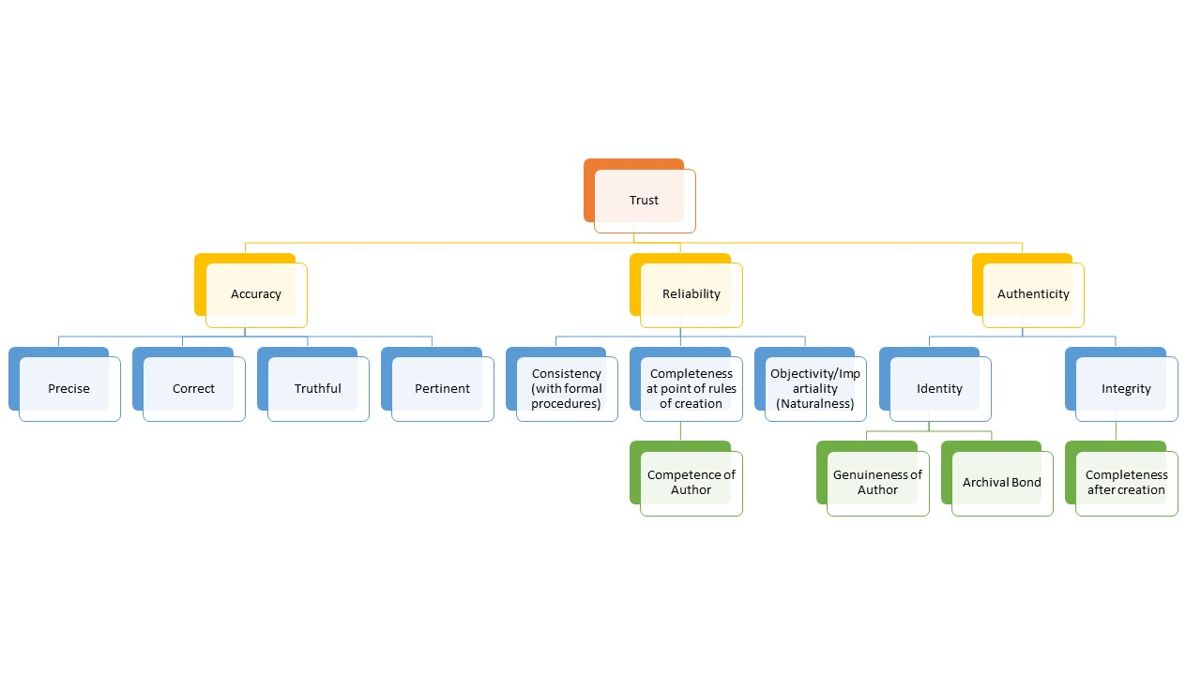
Figure 1: Taxonomy of Trust by Dr. Victoria Lemieux, an expansion of the Ontology of the Trustworthiness of a Record, InterPARES 2 Terminology Cross-domain Task Force;
As seen in the illustration above, trusting records to meet societal needs requires records be accurate, reliable, and authentic. Records are accurate when their content is correct. Records are reliable based upon who creates them and how; an unreliable record cannot be made reliable. A record is authentic when “it is [what] it claims to be, [free from] manipulation, substitution, or falsification” (Duranti, 1995). Thus, ensuring that trustworthy records are available requires policies addressing both the preservation of records, such as through blockchain’s immutability, and the circumstances of their creation – or non-creation. Blockchain solutions alone offer no solution where governments or other actors create forgeries, make errors, or simply refuse to create records in the first place. It must also be noted that blockchain solutions do not preserve the archival bond, the relationships between records that provide each record with its identity and context. Without significantly more development, there is little about blockchain solutions per se that ensures the trustworthiness of records.

Blockchain in Archival Institutions
The use of blockchains and distributed ledger technologies (DLTs) in the archival context is still extremely novel, primarily in the research stage. ARCHANGEL, for example, is an 18 month study between GuardTime (a blockchain purveyor) and UK researchers “to ensure the long-term sustainability of digital archives though the design, development and trialling of transformational new distributed ledger technology (DLT) to promote accessibility and ensure integrity of content, whilst maximising its impact through novel business models for commodification and open access.” It must be noted that the emphasis in ARCHANGEL, as in most blockchain solutions, is on integrity and accessibility. Digital archives encompass a variety of records, both born-digital and digitized; their preservation, arrangement and description, and accessibility require full infrastructures that blockchain solutions are currently too immature to provide. Furthermore, many blockchain solutions use off-chain storage for a variety of reasons, such as accommodating legacy systems, storage beyond the limits of the blockchain, or regulatory limitations. Records generated and stored off-chain remain vulnerable to all of the reliability-related problems that they had before a blockchain was introduced, and integration of such records with a blockchain solution to ensure records’ trustworthiness over time will require thoughtful design to instantiate, for example, the archival bond or access restrictions.

Recommendations
Designing appropriate blockchain policies will require understanding the three tightly-coupled, mutually-dependent layers of blockchain solutions: the social layer, the data/records layer, and the technical layer.
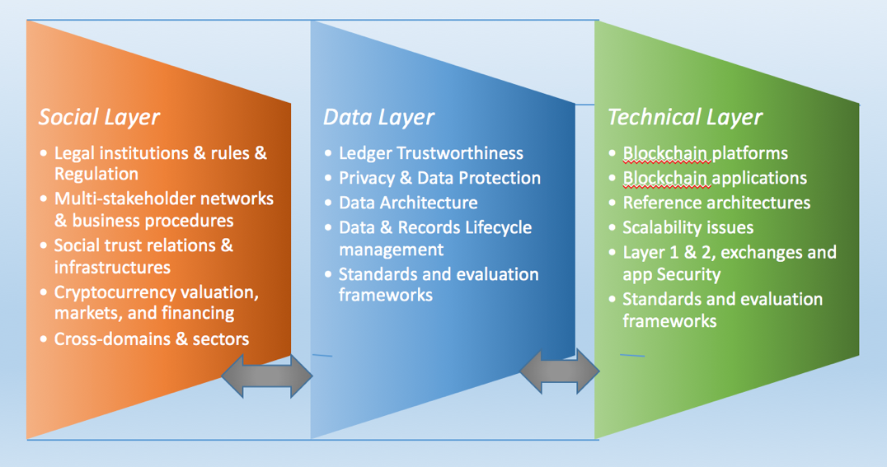
Blockchain solutions to archival problems will require further research to:
- Define the characteristics of archival blockchain solutions;
- Align blockchain solutions with legal, regulatory, technical, and stakeholder requirements;
- Examine blockchain solutions against archival standards such as the Open Archival Information System (OAIS Reference Model, ISO 14721);
- Create interoperable blockchain ecosystems that meet the full suite of archival needs beyond ensuring records integrity.

References
Duranti, L. (1995). Reliability and authenticity: The concepts and their implications. Archivaria, (39), 5-10.

Lemieux, V. L. (2016). Trusting records: Is blockchain technology the answer? Records Management Journal, 26(2), 110-139. 10.1108/RMJ-12-2015-0042

